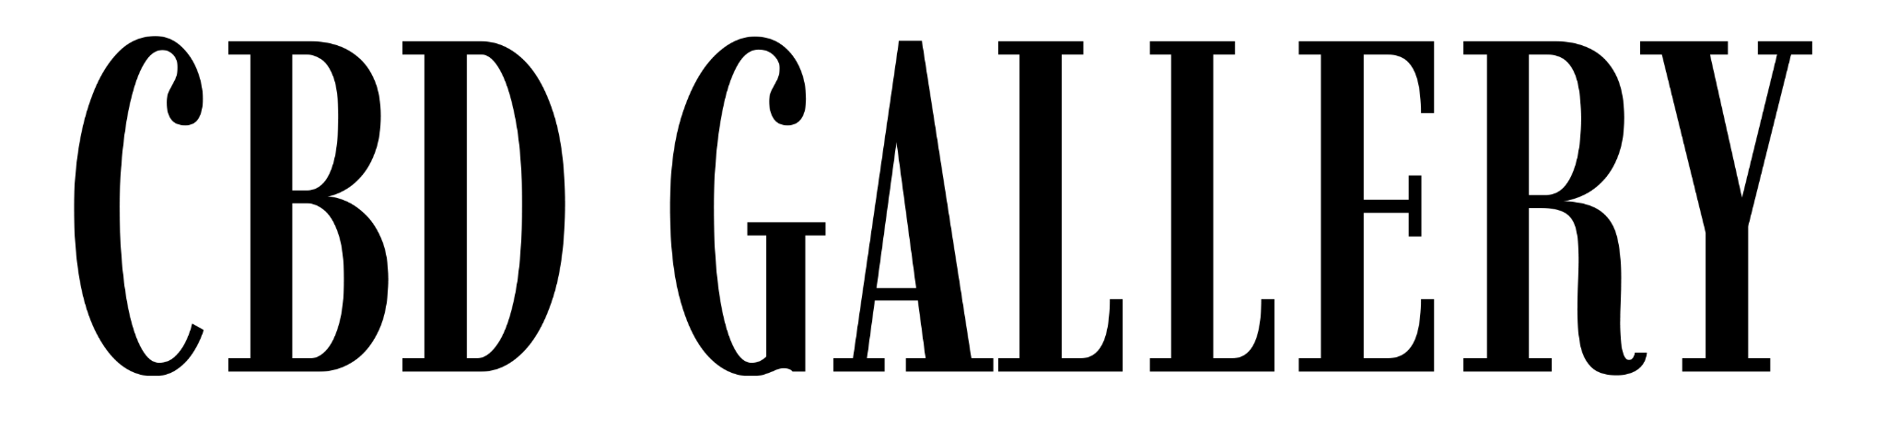

Zi (Sylvia) Xin
Lives and works in Sydney, Australia

Academic Qualifications:
2024: Bachelor of Fine Arts, National Art School, Sydney
2021: Diploma of Visual Arts, St George TAFE, Sydney
2015: Master of Teaching (Early Childhood Education), University of Western Sydney
2012: Bachelor of Arts (Languages), USYD

Selected Groups Shows:
2025: New Voices, CBD Gallery, Sydney
2025: Emanate, New English Regional Art Museum, Armidale
2025: Brunswick Small Work Art Prize, Melbourne
2024: Group Exhibition, IMPULSE, Library Stairwell Gallery, National Art School, Sydney
2022: Shopfronts Artslab, Fearless Identities, 107 Projects, Redfern, Sydney
2021: Group Exhibition, Weaving the light, St George TAFE, Kogarah, Sydney

Awards:
2025: Finalist, Little Things Art Prize
2025: Finalist, Fisher’s Ghost ArtPrize
2025: Finalist, Hornsby Art Prize
2025: Finalist, Georges River Art Prize
2025: Finalist, Blacktown City Art Prize
2024: Claypool Scholarship, National Art School Graduate Awards.

